POP Power from Warhol to Koon: Masterworks from the Collections of Jordan D. Schnitzer and His Family Foundation

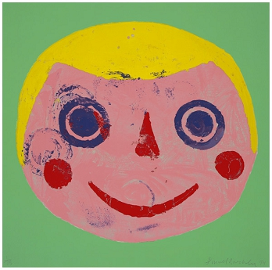  Donald Baechler (American (b. 1956))  Coney Island Portfolio: II, edition 59/75, 1994  screenprint  29 x 29 in.  2010.119b |  | 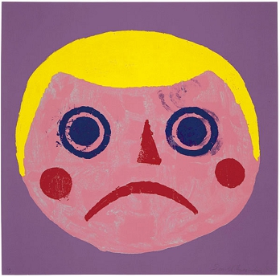  Donald Baechler (American (b. 1956))  Coney Island Portfolio: IV, edition 59/75, 1994  screenprint with flocking  29 x 29 in.  2010.119d
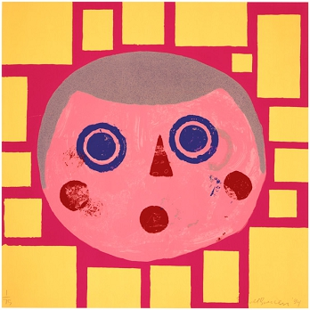  Donald Baechler (American (b. 1956))  Coney Island Portfolio: V, edition 59/75, 1994  screenprint with sand  29 x 29 in.  2010.119e |  | 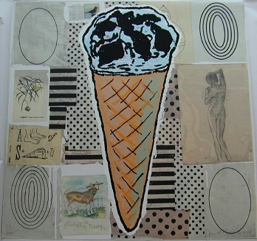  Donald Baechler (American (b. 1956))  Cone, edition 59/60, 2000  screenprint  36 x 36 in.  2000.127b
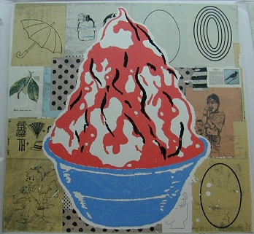  Donald Baechler (American (b. 1956))  Red Sundae, ediiton 59/60, 2000  screenprint  36 x 36 in.  2000.127a |  | 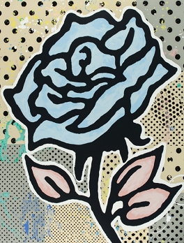  Donald Baechler (American (b. 1956))  Six Roses: Blue Rose, edition 29/35, 2015  silkscreen  40 x 30 3/4 in.  2015.271a
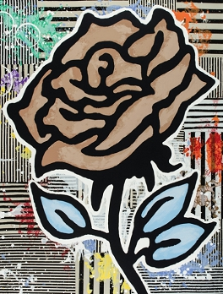  Donald Baechler (American (b. 1956))  Six Roses: Brown Rose, edition 29/35, 2015  silkscreen  40 x 30 3/4 in.  2015.271b |  | 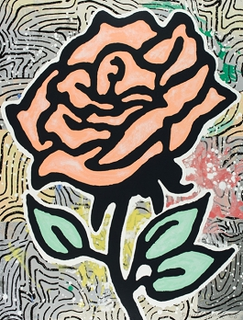  Donald Baechler (American (b. 1956))  Six Roses: Peach Rose, edition 29/35, 2015  silkscreen  40 x 30 3/4 in.  2015.271d
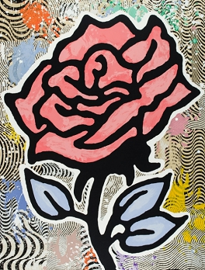  Donald Baechler (American (b. 1956))  Six Roses: Red Rose, edition 29/35, 2015  silkscreen  40 x 30 3/4 in.  2015.271e |  | 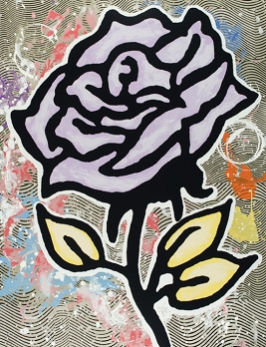  Donald Baechler (American (b. 1956))  Six Roses: Violet Rose, edition 29/35, 2015  silkscreen  40 x 30 3/4 in.  2015.271c
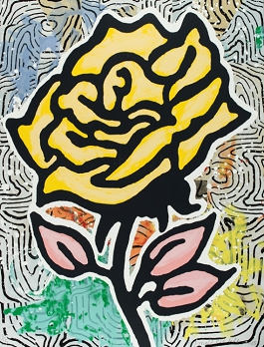  Donald Baechler (American (b. 1956))  Six Roses: Yellow Rose, edition 29/35, 2015  silkscreen  40 x 30 3/4 in.  2015.271f |  | 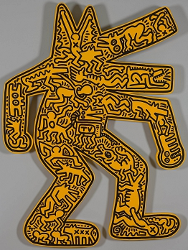  Keith Haring (American (1958-1990))  Dog, edition 10/10, 1986  screenprint on painted wood  50 1/4 x 36 in.  2000.46
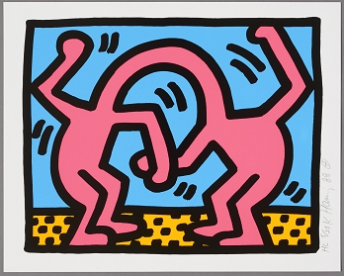  Keith Haring (American (1958-1990))  Pop Shop Quad II, edition HC 5/20, 1988  screenprint  12 x 15 in.  2017.128c |  | 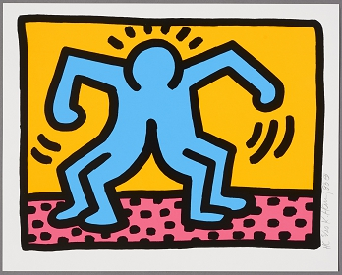  Keith Haring (American (1958-1990))  Pop Shop Quad II, edition HC 5/20, 1988  screenprint  12 x 15 in.  2017.128d
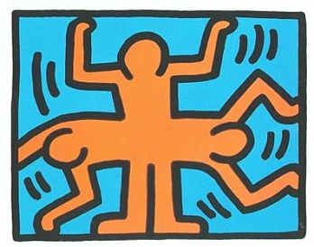  Keith Haring (American (1958-1990))  Pop Shop VI, edition 9/200, 1989  silkscreen  13 1/2 x 16 1/2 in.  2003.48d |  | 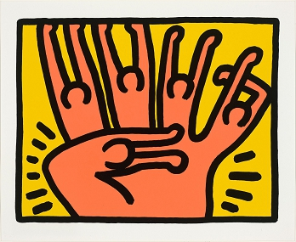  Keith Haring (American (1958-1990))  Pop Shop VI, edition 9/200, 1989  silkscreen  13 1/2 x 16 1/2 in.  2003.48b
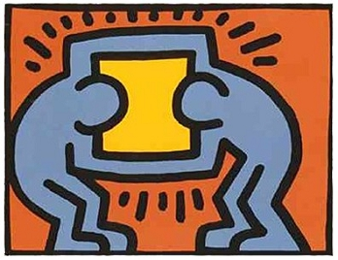  Keith Haring (American (1958-1990))  Pop Shop VI, edition 9/200, 1989  silkscreen  13 1/2 x 16 1/2 in.  2003.48c |  | 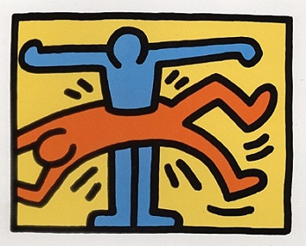  Keith Haring (American (1958-1990))  Pop Shop VI, edition 9/200, 1989  silkscreen  13 1/2 x 16 1/2 in.  2003.48a
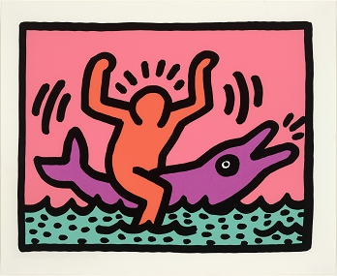  Keith Haring (American (1958-1990))  Pop Shop V, edition 153/200, 1989  silkscreen  13 1/2 x 16 1/2 in.  2003.47b |  | 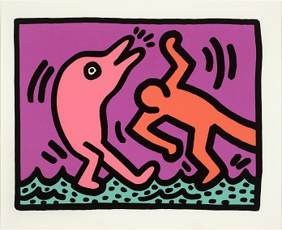  Keith Haring (American (1958-1990))  Pop Shop V, edition 153/200, 1989  silkscreen  13 1/2 x 16 1/2 in.  2003.47d
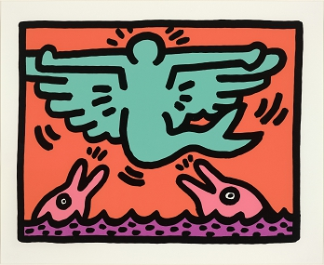  Keith Haring (American (1958-1990))  Pop Shop V, edition 153/200, 1989  silkscreen  13 1/2 x 16 1/2 in.  2003.47c |  | 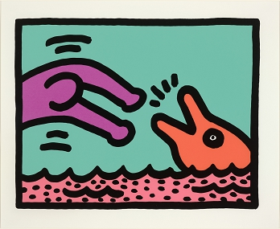  Keith Haring (American (1958-1990))  Pop Shop V, edition 153/200, 1989  silkscreen  13 1/2 x 16 1/2 in.  2003.47a
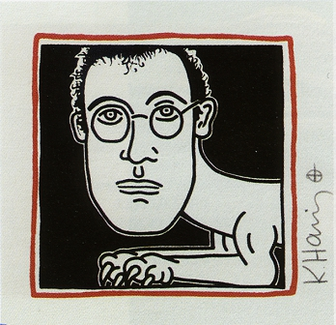  Keith Haring (American (1958-1990))  Self-Portrait (Invitation), proof, 1985  screenprint  6 X 6 inches  2007.76 |  | 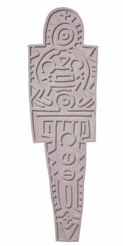  Keith Haring (American (1958-1990))  Totem (Concrete), edition 24/25, 1988-89  concrete  71 7/8 x 21 1/2 x 2 in.  2018.215
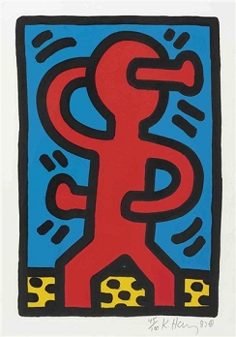  Keith Haring (American (1958-1990))  Untitled, edition A 1/100, 1987  screenprint  14 3/4 x 11 in.  1993.6 |  | 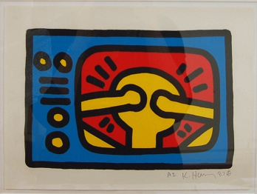  Keith Haring (American (1958-1990))  Untitled, edition A 1/100, 1987  screenprint  11 x 14 3/4 in.  1993.22
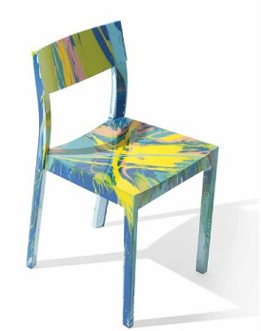  Damien Hirst (British (b. 1965))  Beautiful Arrested Development Spin Chair, 2014  painted chair  31 x 17 x 16 3/8 in.  2016.84 |  | 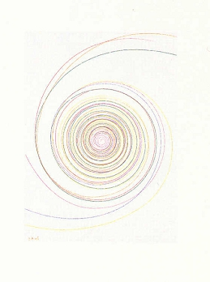  Damien Hirst (British (b. 1965))  In a Spin, The Action of the World on Things, Volume I: Billy Mill Roundabout, edition 56/68, 2002  etching  36 x 28 in.  2005.166q
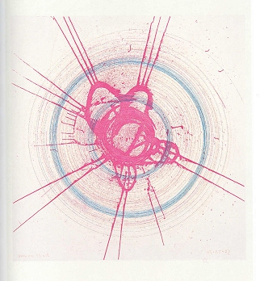  Damien Hirst (British (b. 1965))  In a Spin, The Action of the World on Things, Volume I: Global-a-Go-Go - For Joe, edition 56/68, 2002  etching  36 x 28 in.  2005.166h |  | 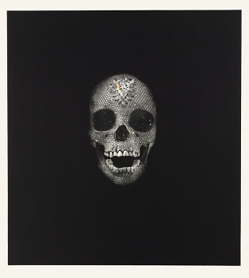  Damien Hirst (British (b. 1965))  Memento: Victory Over Death, edition 3/30, 2008  photogravure etching  47 1/4 x 42 1/2 in.  2008.138m
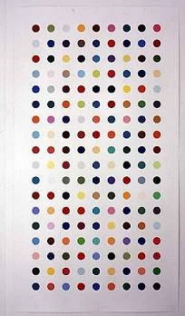  Damien Hirst (British (b. 1965))  Methamphetamine, edition 57/115, 2004  etching  80 x 43 in.  2004.212 |  | 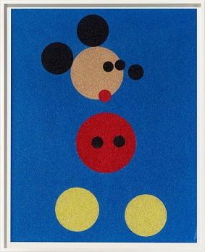  Damien Hirst (British (b. 1965))  Mickey, edition 15/50, 2016  silkscreen with glitter  60 x 48 in.  2018.111
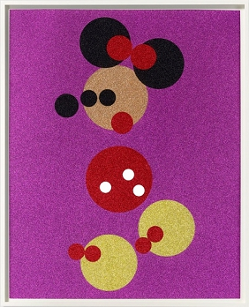  Damien Hirst (British (b. 1965))  Minnie, edition 15/50, 2016  silkscreen with glitter  60 x 48 in.  2018.112 |  | 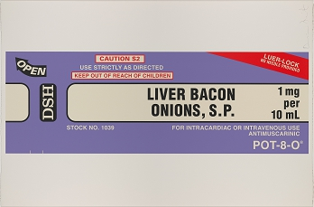  Damien Hirst (British (b. 1965))  The Last Supper: Liver, Bacon, Onions, S.P., edition of 150, 1999  screenprint  40 x 60 in.  2002.47f
Damien Hirst (British (b. 1965))  The Last Supper: Steak and Kidney Pie, edition of 150, 1999  screenprint  60 x 40 in.  2002.47c |  | Damien Hirst (British (b. 1965))  40 Woodcut Spots: Amniotic Fluid, edition 49/55, 2011-12  color woodcut  12 1/8 x 12 1/8 in.  2014.165d
Damien Hirst (British (b. 1965))  40 Woodcut Spots: Equilin, edition 49/55, 2011-12  color woodcut  12 1/8 x 12 1/8 in.  2014.165j |  | 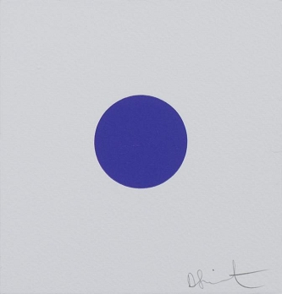  Damien Hirst (British (b. 1965))  40 Woodcut Spots: Isostearic Acid, edition 49/55, 2011-12  color woodcut  6 1/8 x 6 1/8 in.  2014.165u
Damien Hirst (British (b. 1965))  40 Woodcut Spots: Mepartricin, edition 49/55, 2011-12  color woodcut  12 1/8 x 12 1/8 in.  2014.165aa |  | 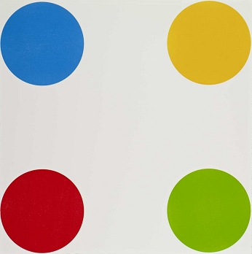  Damien Hirst (British (b. 1965))  40 Woodcut Spots: Norcamphor, edition 49/55, 2011-12  color woodcut  24 x 24 in.  2014.165ii
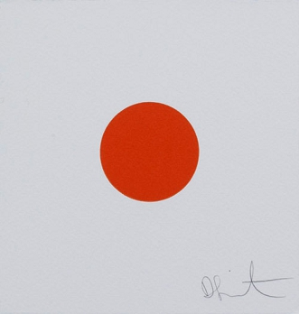  Damien Hirst (British (b. 1965))  40 Woodcut Spots: Oleandrigenin, edition 49/55, 2011-12  color woodcut  6 1/8 x 6 1/8 in.  2014.165mm |  | 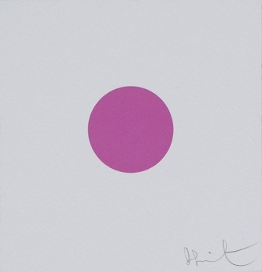  Damien Hirst (British (b. 1965))  40 Woodcut Spots: Picrotoxin, edition 49/55, 2011-12  color woodcut  6 1/8 x 6 1/8 in.  2014.165dd
Damien Hirst (British (b. 1965))  40 Woodcut Spots: Quisqualic Acid, edition 49/55, 2011-12  color woodcut  12 1/8 x 12 1/8 in.  2014.165q |  | 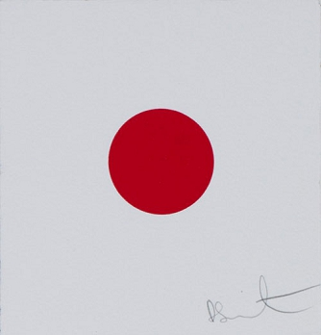  Damien Hirst (British (b. 1965))  40 Woodcut Spots: Rhodotorulic Acid, edition 49/55, 2011-12  color woodcut  6 1/8 x 6 1/8 in.  2014.165hh
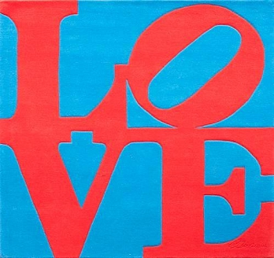  Robert Indiana (American (b. 1928))  Red on Blue Love, edition 153/200, n.d.  wool tapestry wove from skein dyed, hand-carved and hand-tufted archival New Zealand wood  72 x 72 in.  2008.228 |  | 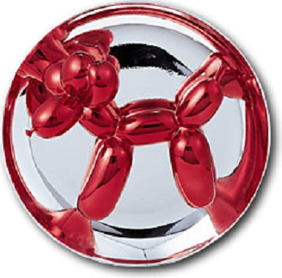  Jeff Koons (American (b. 1955))  Balloon Dog (Red), 2046/2300, 1995  ceramic  10 1/2 x 10 1/2 x 4 1/2 in.  2003.192
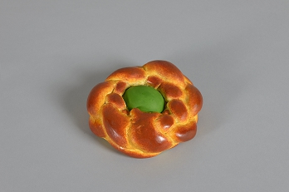  Jeff Koons (American (b. 1955))  Bread with Egg (green), 154/250, 1995  hand-painted egg tempera sculptures made of hydrocal  6 x 5 3/8 x 2 in.  2006.26 |  | 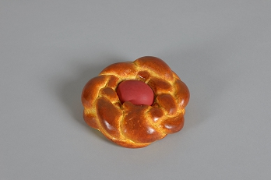  Jeff Koons (American (b. 1955))  Bread with Egg (red), 182/250, 1995  hand-painted egg tempera sculptures made of hydrocal  6 x 5 3/8 x 2 in.  2006.24
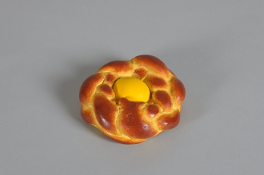  Jeff Koons (American (b. 1955))  Bread with Egg (yellow), 228/250, 1995  hand-painted egg tempera sculptures made of hydrocal  6 x 5 3/8 x 2 in.  2006.25 |  | 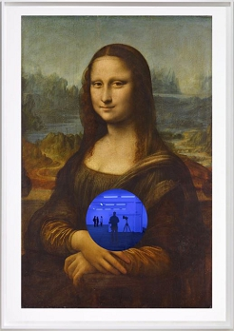  Jeff Koons (American (b. 1955))  Gazing Ball (da Vinci Mona Lisa), edition 38/40, 2016  archival pigment print with inlaid mirrored glass  40 11/16 x 27 3/4 in.  2018.40
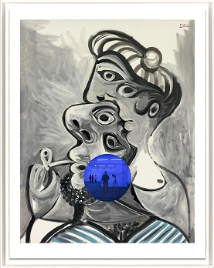  Jeff Koons (American (b. 1955))  Gazing Ball (Picasso Couple), edition 5/20, 2017  archival pigment print, glass  40 7/8 x 32 3/16 in.  2018.81 |  | 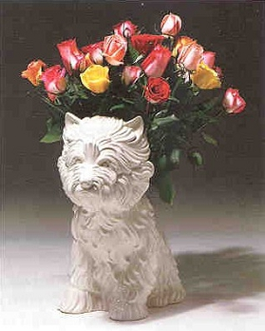  Jeff Koons (American (b. 1955))  Puppy, edition 1821/3000, 1998  ceramic  17 3/4 x 14 in.  2005.342
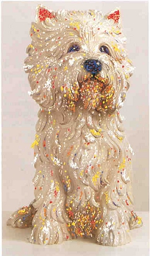  Jeff Koons (American (b. 1955))  Puppy, edition 49/75, 1998  lithograph and screenprint  42 x 25 1/2 in.  2001.25 |  | 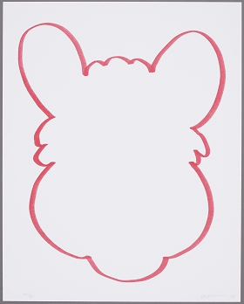  Jeff Koons (American (b. 1955))  Sequences: Fun, edition 44/60, 1998  lithograph, coated board  19 5/8 x 15 3/4 in.  2001.23c
Jeff Koons (American (b. 1955))  Sequences: Fun, edition 44/60, 1998  lithograph, coated board  19 5/8 x 15 3/4 in.  2001.23a |  | 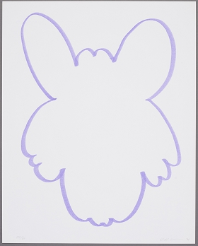  Jeff Koons (American (b. 1955))  Sequences: Fun, edition 44/60, 1998  lithograph, coated board  19 5/8 x 15 3/4 in.  2001.23b
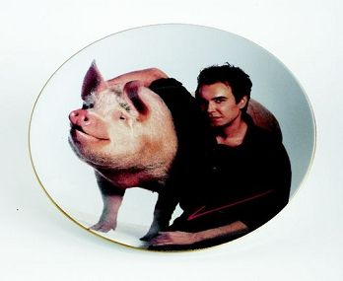  Jeff Koons (American (b. 1955))  Signature Plate (for Parkett no. 19), edition 48/80, 1989  porcelain with photolithographic decal  11 in.  2009.98 |  | 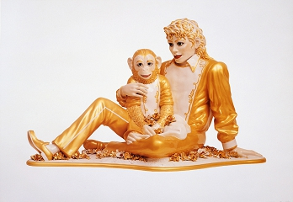  Jeff Koons (American (b. 1955))  Untitled Portfolio, Michael Jackson and Bubbles, edition 35/50, 1995  offset lithograph  27 3/8 x 39 1/8 in.  2001.24e
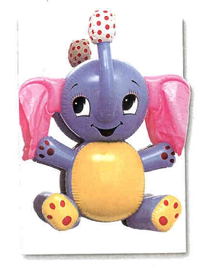  Jeff Koons (American (b. 1955))  Untitled Portfolio, Wall Object, edition 35/50, 1995  stainless steel, plastic  40 5/8 x 28 3/4 x 2 in.  2001.24h |  | 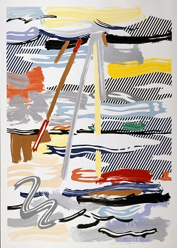  Roy Lichtenstein (American (1923-1997))  Landscape Series: Sunshine through the Clouds, edition 41/60, 1985  lithograph, woodcut and screenprint  55 1/2 x 40 in.  2005.37
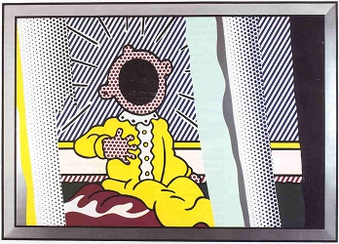  Roy Lichtenstein (American (1923-1997))  Reflections Series: Reflections on The Scream, edition 53/68, 1990  lithograph, screenprint, woodcut, and metallized PVC collage with embossing  48 3/4 x 65 3/8 in.  1998.17 |  | 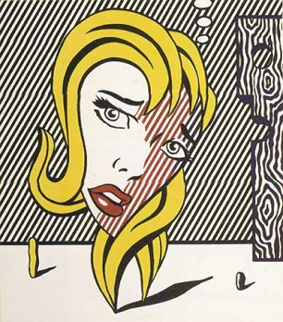  Roy Lichtenstein (American (1923-1997))  Surrealist Series: Blonde, edition 2/38, 1978  lithograph  29 3/4 x 27 in.  2005.33
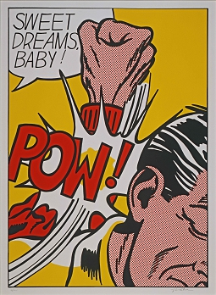  Roy Lichtenstein (American (1923-1997))  Sweet Dreams Baby!, plate 1 from the Portfolio 11 Pop Artists, Vol. III, edition 54/200, 1965  screenprint  37 7/8 x 27 5/8 in.  2008.242e |  | 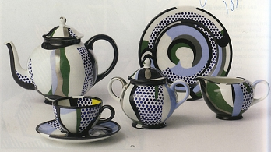  Roy Lichtenstein (American (1923-1997))  Tea Service, edition AP, 1984  ceramic  case: 26 1/4 x 20 1/4 x 7 3/4 inches  2008.130a-v
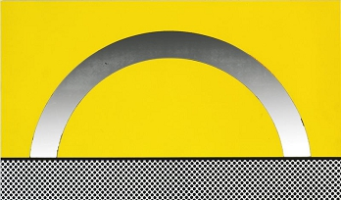  Roy Lichtenstein (American (1923-1997))  Ten Landscapes: Landscape 7, edition 56/100, 1967  screenprint on four-ply board, with iridescent silver Mylar, tipped onto composition board  16 5/8 x 21 1/2 in.  2012.161g |  | 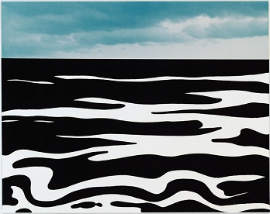  Roy Lichtenstein (American (1923-1997))  Ten Landscapes: Landscape 9, edition 56/100, 1967  screenprint with color chromogenic photographic print, laid down on four-ply rag board, tipped down onto composition board  16 5/8 x 21 1/2 in.  2012.161i
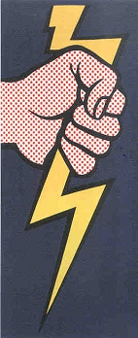  Roy Lichtenstein (American (1923-1997))  Thunderbolt, edition 19/20, 1966  felt  101 x 44 1/2 in.  2000.118 |  | 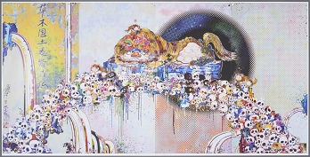  Takashi Murakami (Japanese (b. 1962))  As the Interdimensional Waves Run Through Me, I Can Distinguish Between the Voices of Angel and Devil!, edition 130/300, 2012  lithograph  28 x 55 in.  2015.263
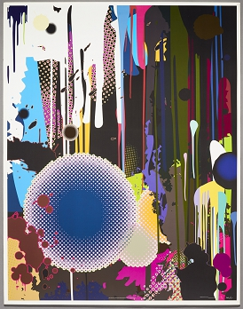  Takashi Murakami (Japanese (b. 1962))  Davy Jones' Tear, edition 212/300, 2009  offset print  32 5/8 x 25 1/2 in.  2018.247 |  | 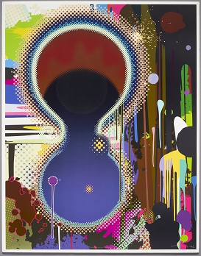  Takashi Murakami (Japanese (b. 1962))  Dumb Compass, edition 149/300, 2009  offset print  32 5/8 x 25 1/2 in.  2018.248
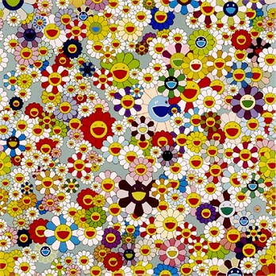  Takashi Murakami (Japanese (b. 1962))  Flowers (Superflat), edition 223/300, 2004  offset lithograph  27 x 27 in.  2005.212 |  | 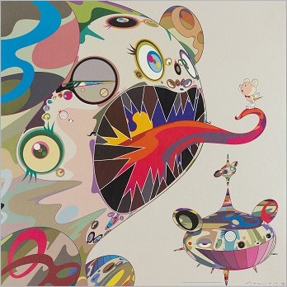  Takashi Murakami (Japanese (b. 1962))  Homage to Francis Bacon (George Dyer), edition 19/300, 2004  lithograph  26 3/4 x 26 3/4 in.  2005.190
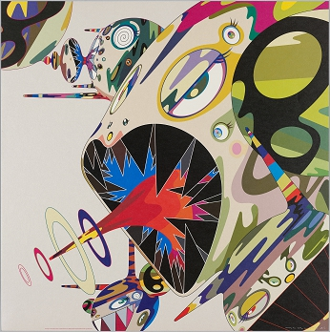  Takashi Murakami (Japanese (b. 1962))  Homage to Francis Bacon (Isabel Rawsthorne), edition 26/300, 2004  lithograph  26 3/4 x 26 3/4 in.  2005.191 |  | 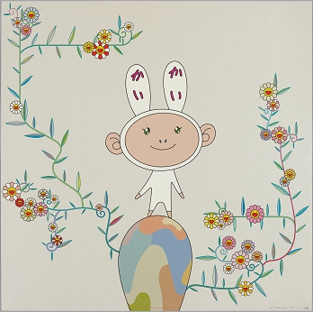  Takashi Murakami (Japanese (b. 1962))  Kaikai with Moss, edition 146/300, 2004  lithograph  26 3/4 x 26 3/4 in.  2005.194
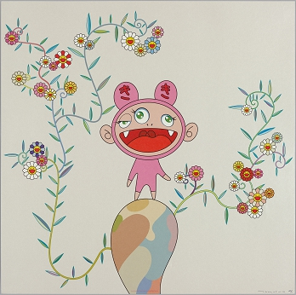  Takashi Murakami (Japanese (b. 1962))  Kiki with Moss, edition 198/300, 2004  lithograph  26 3/4 x 26 3/4 in.  2005.195 |  | 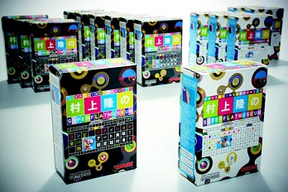  Takashi Murakami (Japanese (b. 1962))  Superflat Museum, 2000  plastic  2009.77a-p
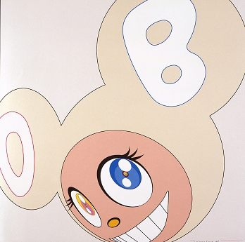  Takashi Murakami (Japanese (b. 1962))  White DOB, edition 19/300, 2004  lithograph  26 3/4 x 26 3/4 in.  2005.192 |  | 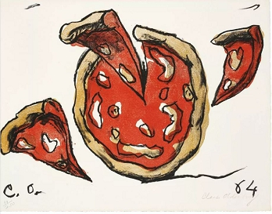  Claes Oldenburg (American, born Sweden (b.1929))  Flying Pizza, from the portfolio New York 10, edition 99/200, 1964, published 1965  lithograph  17 x 22 3/16 in.  2018.59h
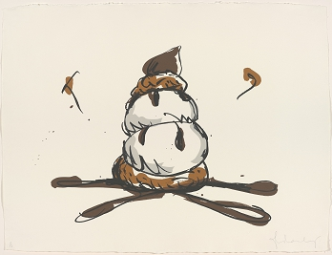  Claes Oldenburg (American, born Sweden (b.1929))  Profiterole, edition 15/57, 1990  lithograph  30 3/4 x 40 1/4 in.  2005.29 |  | 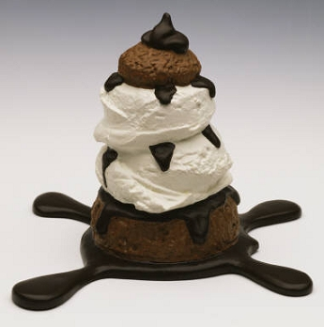  Claes Oldenburg (American, born Sweden (b.1929))  Profiterole, edition 42/75, 1990  cast aluminum  5 7/8 x 6 5/8 x 6 3/8 in.  1999.103
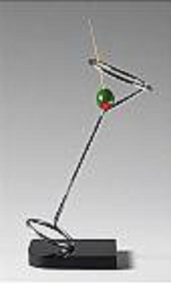  Claes Oldenburg (American, born Sweden (b.1929))  Tilting Neon Cocktail, edition 23/50, 1983-84  stainless steel, plastic and wood  18 3/4 x 6 1/4 x 7 in.  2004.145 |  | 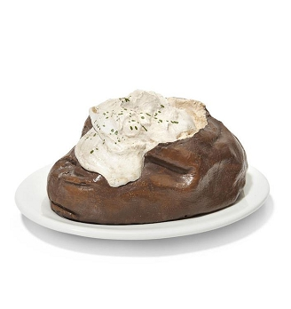  Claes Oldenburg (American, born Sweden (b.1929))  7 Objects in a Box: Baked Potato, edition 67/75, 1966  molded aluminum, fiberglas and polyester metal handpainted with synthetic polymer color paint on a white Shenango china plate  Object Size: 4 x 8 x 4 5/8 inches; Plate Size: 1 x 10 1/2 x 7 3/8in  2018.437
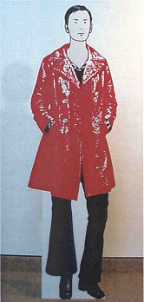  Julian Opie (British (b.1958))  Angelica, Visitor, edition 1/3, 1999  inkjet on foamex  68 x 21 x 10 in.  2000.102 |  | 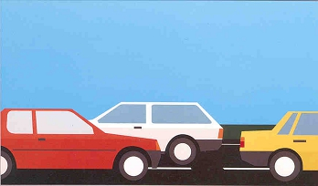  Julian Opie (British (b.1958))  Cars?, edition 34/40, 1998-99  screenprint  24 x 41 1/8 in.  2002.45b
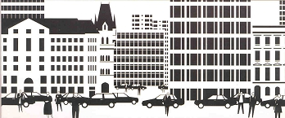  Julian Opie (British (b.1958))  Cityscape?, edition 34/40, 1998-99  screenprint  24 x 57 1/8 in.  2002.45c |  | 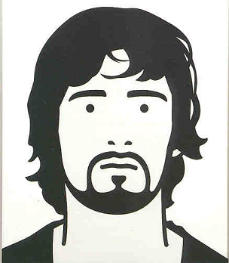  Julian Opie (British (b.1958))  Gary, popstar, edition 34/40, 1998-99  screenprint  24 x 20 7/8 in.  2002.45e
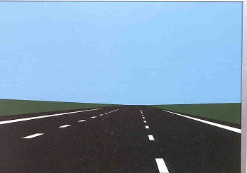  Julian Opie (British (b.1958))  Imagine You Are Driving, edition 34/40, 1998-99  screenprint  24 x 33 7/8 in.  2002.45f |  | 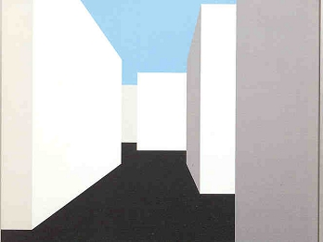  Julian Opie (British (b.1958))  Imagine You Are Walking, edition 34/40, 1998-99  screenprint  24 x 31 1/8 in.  2002.45d
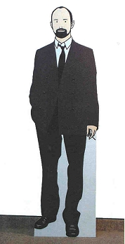  Julian Opie (British (b.1958))  Keith, Brother-In-Law, edition 2/3, 1999  inkjet on foamex  70 1/4 x 21 x 10 in.  2000.101 |  | 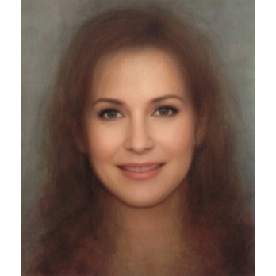  Richard Prince (American (b. 1949))  Untitled (Girlfriend), edition 12/57, 2013  pigment print on canvas  60 x 50 in.  2013.133
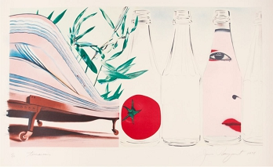  James Rosenquist (American (b. 1933))  Terrarium, edition 41/100, 1978  lithograph  29 1/4 x 44 3/4 in.  2018.211 |  | 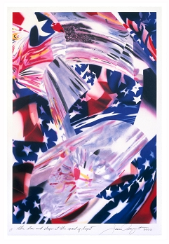  James Rosenquist (American (b. 1933))  The Stars and Stripes at the Speed of Light, edition PP 3/6, 2000  lithograph  45 1/2 x 31 in.  2018.258
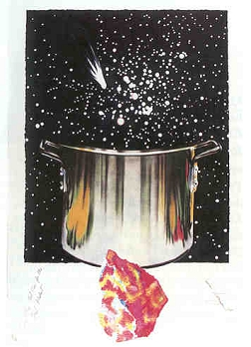  James Rosenquist (American (b. 1933))  Welcome to the Water Planet: Caught One Lost One for the Fast Student or Star Catcher, edition 15/92, 1989  lithograph and collage  54 1/2 x 38 in.  2001.66 |  | 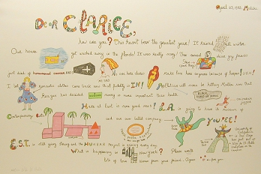  Niki de Saint-Phalle (French (1930-2002))  Untitled (from Eight by Eight to Celebrate the Temporary Contemporary), edition 161/250, 1983  lithograph  42 x 29 in.  2001.62f
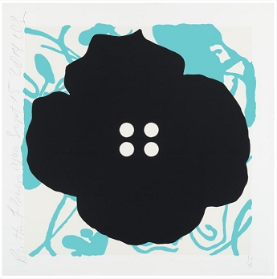  Donald Sultan (American (b. 1951))  Button Flower Aqua, Sept 15, 2014, edition 26/35, 2014  color silkscreen with enamel ink and flocking on 2-ply museum board  30 x 29 7/8 in.  2016.218a |  | 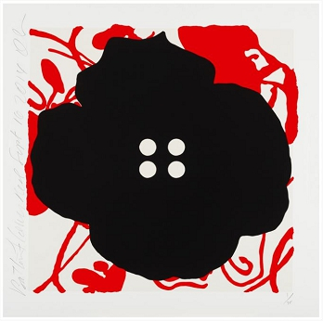  Donald Sultan (American (b. 1951))  Button Flower Red, Sept 16, 2014, edition 26/35, 2014  color silkscreen with enamel ink and flocking on 2-ply museum board  30 1/8 x 30 1/8 in.  2016.218b
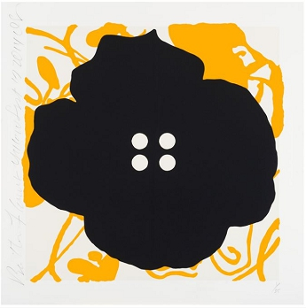  Donald Sultan (American (b. 1951))  Button Flower Yellow, Sept 17, 2014, edition 26/35, 2014  color silkscreen with enamel ink and flocking on 2-ply museum board  30 x 29 7/8 in.  2016.218c |  | 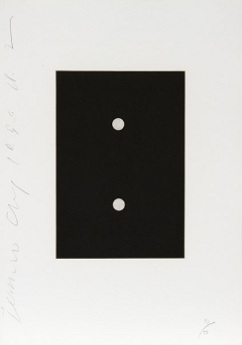  Donald Sultan (American (b. 1951))  Dominoes, edition AP 10/10, 1990  aquatint  21 1/4 x 15 in.  2006.406d
Donald Sultan (American (b. 1951))  Dominoes, edition AP 10/10, 1990  aquatint  21 1/4 x 15 in.  2006.406a |  | 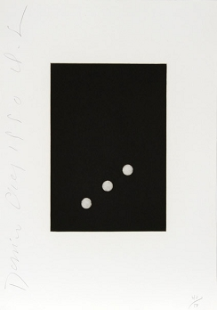  Donald Sultan (American (b. 1951))  Dominoes, edition AP 10/10, 1990  aquatint  21 1/4 x 15 in.  2006.406g
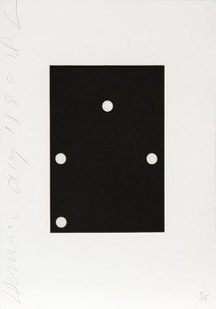  Donald Sultan (American (b. 1951))  Dominoes, edition AP 10/10, 1990  aquatint  21 1/4 x 15 in.  2006.406h |  | 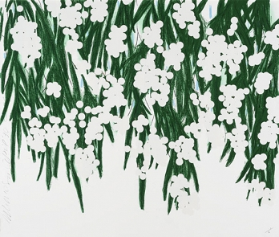  Donald Sultan (American (b. 1951))  Mimosa, April 30, 2015, edition of 40, 2015  silkscreen with flocking  51 x 60 in.  2015.276
Donald Sultan (American (b. 1951))  Red Lantern Flowers, April 16, 2014, edition of 6, 2014  painted aluminum on polished stainless steel base  59 x 65 3/4 x 11 in.  2015.277 |  | 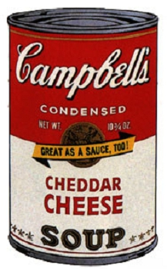  Andy Warhol (American (1928-1987))  Campbell's Soup II: Cheddar Cheese (II.63), edition 174/250, 1969  screenprint  35 x 23 in.  1998.31
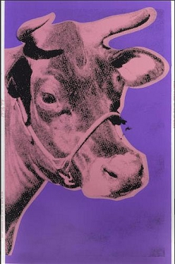  Andy Warhol (American (1928-1987))  Cow (F.S. II.12A), 1976  screenprint on wallpaper  45 1/2 x 29 5/8 in.  2015.837 |  | 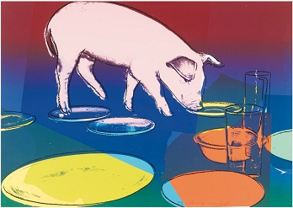  Andy Warhol (American (1928-1987))  Fiesta Pig, edition AP 8/10, 1979  screenprint  21 1/2 x 30 1/2 in.  2015.222
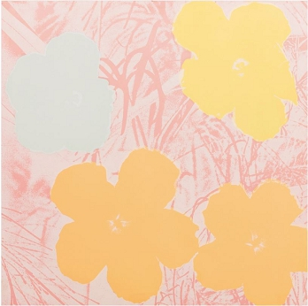  Andy Warhol (American (1928-1987))  Flowers (II.70), edition 66/250, 1970  screenprint  35 5/8 x 35 5/8 in.  2016.110 |  | 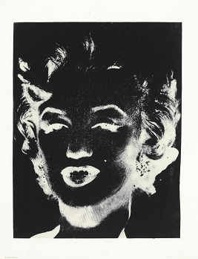  Andy Warhol (American (1928-1987))  Marilyn Monroe (Marilyn), 1978 circa  screenprint  22 3/8 x 17 1/2 in.  2018.442
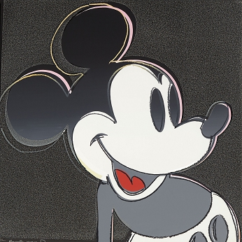  Andy Warhol (American (1928-1987))  Myths: Mickey Mouse (II.265), edition 5/200, 1981  screenprint with diamond dust  38 x 38 in.  2018.443h |  | 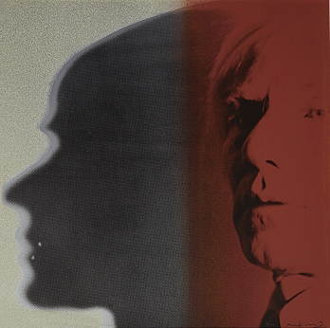  Andy Warhol (American (1928-1987))  Myths: The Shadow (II.267), edition 5/200, 1981  screenprint with diamond dust  38 x 38 in.  2018.443j
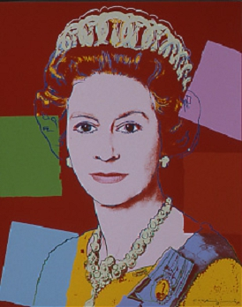  Andy Warhol (American (1928-1987))  Reigning Queens (Royal Edition): Queen Elizabeth II of the United Kingdom (II.334A), edition HC 2/2, 1985  screenprint with diamond dust  39 1/2 x 31 1/2 in.  2003.129a |  | 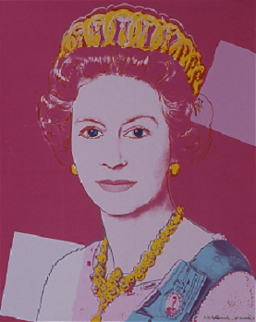  Andy Warhol (American (1928-1987))  Reigning Queens (Royal Edition): Queen Elizabeth II of the United Kingdom (II.336A), edition HC 2/2, 1985  screenprint with diamond dust  39 1/2 x 31 1/2 in.  2003.129c
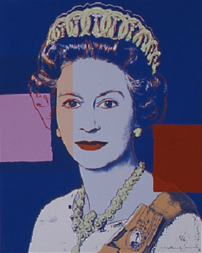  Andy Warhol (American (1928-1987))  Reigning Queens (Royal Edition): Queen Elizabeth II of the United Kingdom (II.337A), edition HC 2/2, 1985  screenprint with diamond dust  39 1/2 x 31 1/2 in.  2003.129d |  | 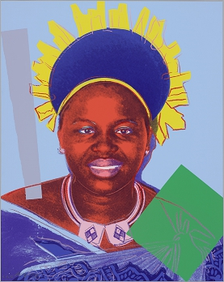  Andy Warhol (American (1928-1987))  Reigning Queens (Royal Edition): Queen Ntombi Twala of Swaziland (II.347A), edition HC 2/2, 1985  screenprint with diamond dust  39 1/2 x 31 1/2 in.  2003.129n
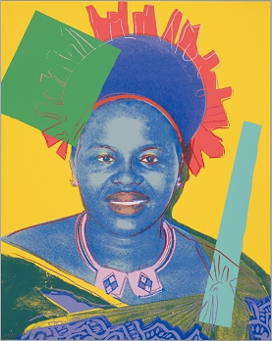  Andy Warhol (American (1928-1987))  Reigning Queens (Royal Edition): Queen Ntombi Twala of Swaziland (II.348A), edition HC 2/2, 1985  screenprint with diamond dust  39 1/2 x 31 1/2 in.  2003.129o |  | 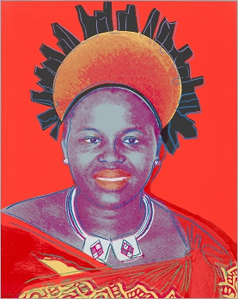  Andy Warhol (American (1928-1987))  Reigning Queens (Royal Edition): Queen Ntombi Twala of Swaziland (II.349A), edition HC 2/2, 1985  screenprint with diamond dust  39 1/2 x 31 1/2 in.  2003.129p

